29th Student Delegation to Ometepe Island, Nicaragua: ~ June 22 to ~ July 6, 2020
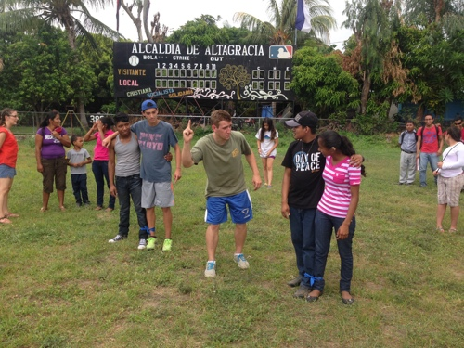
High school students in grades 10, 11, and 12 from Bainbridge Island and neighboring communities who are interested in person-to-person interaction with Bainbridge’s sister island community in Nicaragua are invited to apply to join the 29th student delegation to Ometepe.
Bainbridge Ometepe Sister Islands Association (BOSIA) has been taking students to Nicaragua since 1990. The primary goal of these delegations is to encourage hands-on cultural experiences to build deeper relationships between our students and the people of Ometepe. Students develop new perspectives on global issues while learning to communicate in Spanish. Our past student delegates agree that this is an immensely powerful and unforgettable growth experience.
While on Ometepe, each delegate stays with a host family in a community, with up to six students and at least one Spanish-speaking chaperone placed in each town. Host families are not paid; rather, the students and chaperones “give back” by working with local community members in their host town on a community project.
Cost is approximately $2100 per delegate (dependent on price of airline tickets). This covers all expenses, including airfare. Host families on Ometepe provide a bed and simple meals for the delegates at no charge. Students contribute funds to a community service project in their town. Students pay for their own “extras” and souvenirs. Delegates may apply to BOSIA for partial scholarships based on need. The scholarships are funded by community contributions to BOSIA through One Call for All.
Informational Meeting. You and your parents/guardians are invited to attend an informational meeting on Thursday, October 17th from 7-8:30pm at Hyla Middle School, 7861 Bucklin Hill Rd. Bainbridge Island.
Application & Deposit: to apply complete these 3 steps by Monday, Nov. 4th: (1) Download the application form at http://bainbridgeometepe.org/delegate-resources “Student Delegate Application”, (2) Email application to applications@ometepe.net and (3) send an initial deposit of $250 (checks made out to BOSIA) to BOSIA Student Delegation, PO Box 4484, Rolling Bay, WA 98061. Checks will be returned to those not selected.
Interviews♦final payment♦scholarships: Applicant interviews will be held on November 18th. Delegates will be informed of acceptance by November 22nd. Final payment for delegates will be due in March 2020. Applications for partial scholarships are due by December 16th. If you are interested in a scholarship, email Betsy Carroll: pbcarroll@gmail.com
*** General Schedule ♦ All Meetings are Mandatory ***
October 17, 2019, 7PM: Informational Meeting, Hyla Middle School
November 4, 2019: Last date to submit applications (see 3 application steps above)
November 18, 2019: Group interviews after school at BHS
November 22, 2019: Delegates will be notified
December 2019: Town Group placement and first town meeting
January 2020 through June 2020 (details TBA):
- monthly meetings of Town Groups
- History/Culture Orientation with delegates (January)
- Medical Orientation with delegates, parents and guardians (February)
- Possible Auction & Dinner (with planning meetings leading up to the event) (date & month TBD)
- Overnight Retreat that includes additional BOSIA/Nicaragua history, role plays, cultural sensitivity workshop, packing demo, cooking, games and team building (April/May)
- Packing Party to pack suitcases with aid donations and review packing for personal items (early June)
June 22 - July 6, 2020: Trip to Ometepe (approx. dates, subject to airline reservations)
July 2020: post-trip potluck (approx. dates)
September 2020: students and chaperones give a presentation to the BOSIA community about the trip

Bainbridge Island School District does not sponsor this event, and the district assumes no responsibility for it. In consideration of the privilege to distribute materials, the Bainbridge Island School District shall be held harmless from any cause of action filed in any court or administrative tribunal arising out of the distribution of these materials, including costs, attorney's fees, and judgments or awards.

